**ASSIGNMENT for First Year, First Semester (22-Batch), ELECTRICAL ENGINEERING DEPARTMENT**

**1) Generate a hollow diamond pattern with asterisks (stars) in C++ as given below.**

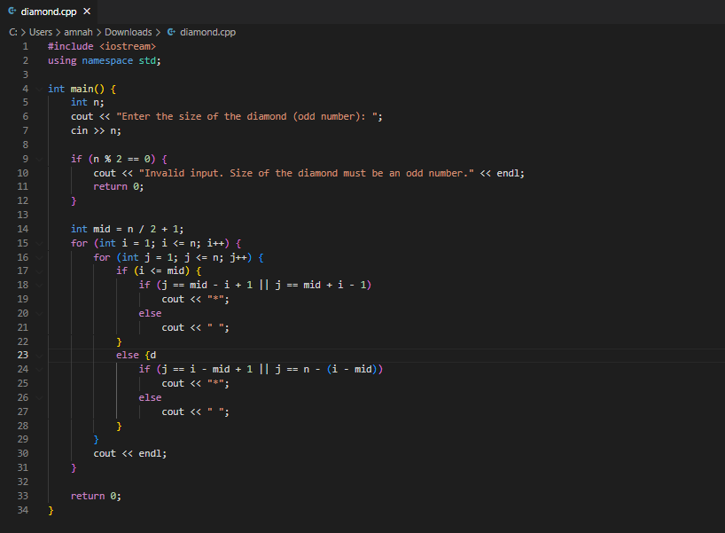

**Output :**

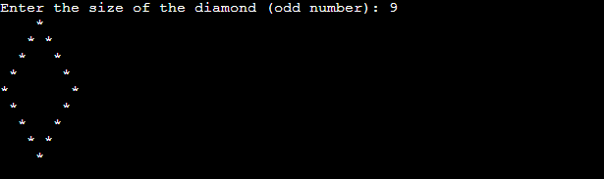

**2) Generate Pascal’s triangle in C++ as given below,**

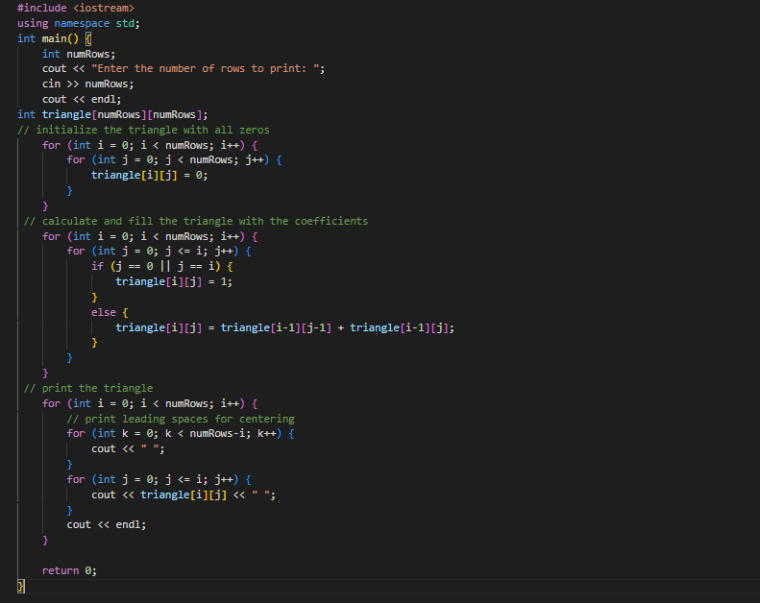

**Output :**

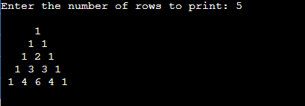

**3) Generate Leibnitz Harmonic triangle in C++ as given below,**

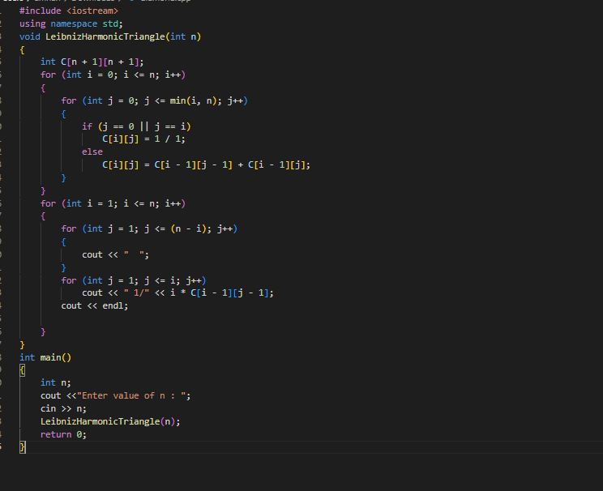

**Output :**

